**Screenshots of the SWE 645 - Assignment2**

1. **Git hub repository:**

1. **Docker Desktop:**

1. **Dockerfile:**

1. **Creating an instance in AWS EC2:**

1. **EC2 connect to ubuntu and Docker command:**

1. **Rancher UI:**

1. **Kubeconfig.yaml file:**

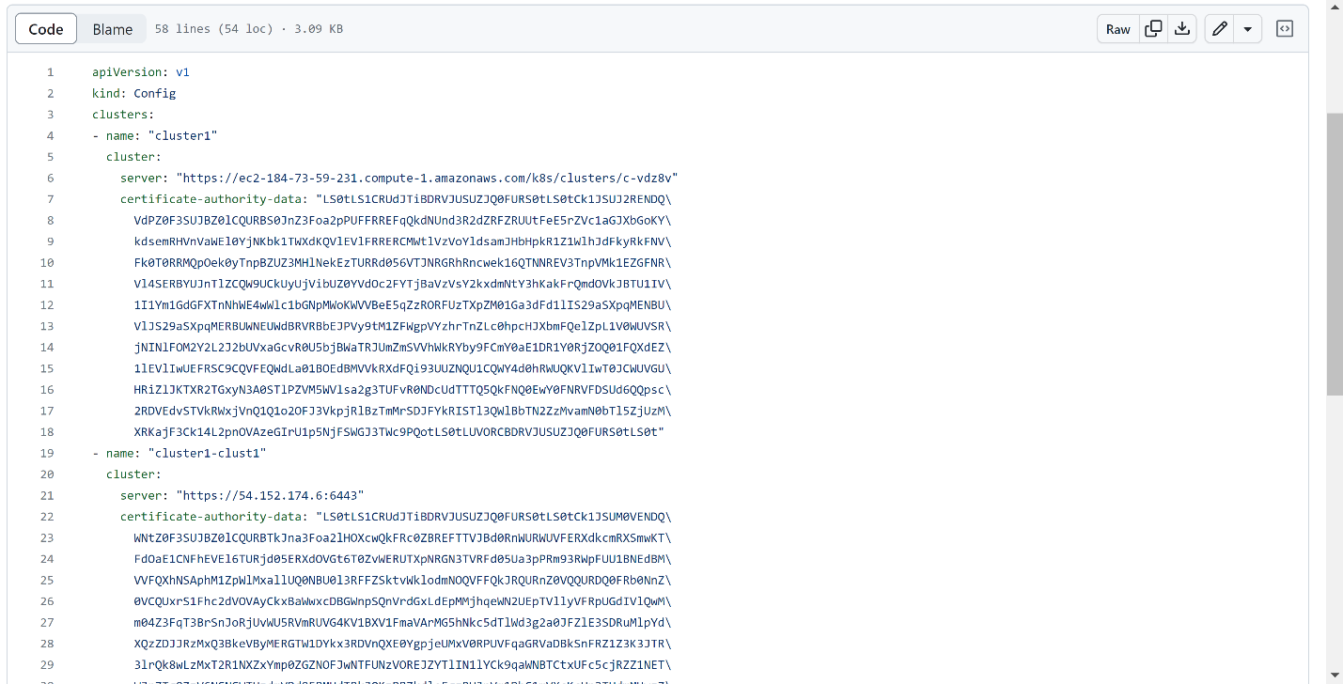

1. **Creating Project and Namespace and creating Deployments:**

1. **Jenkins Dashboard:**

1. **Jenkinsfile:**

1. **Stage View after the pipeline is setup:**

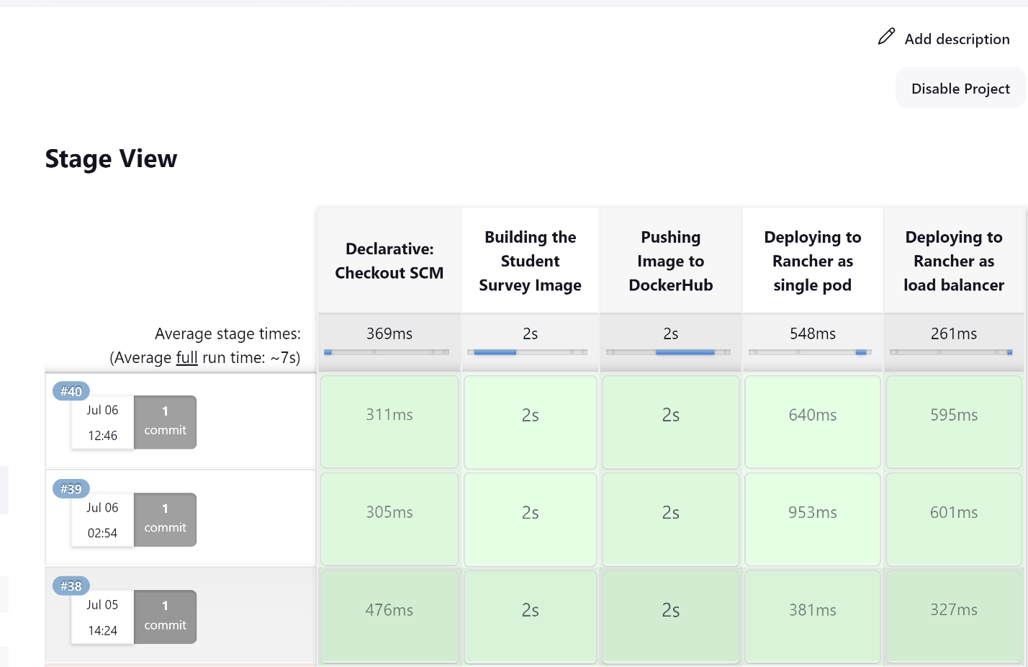

1. **Image pushed to docker hub with update tag as time stamp:**

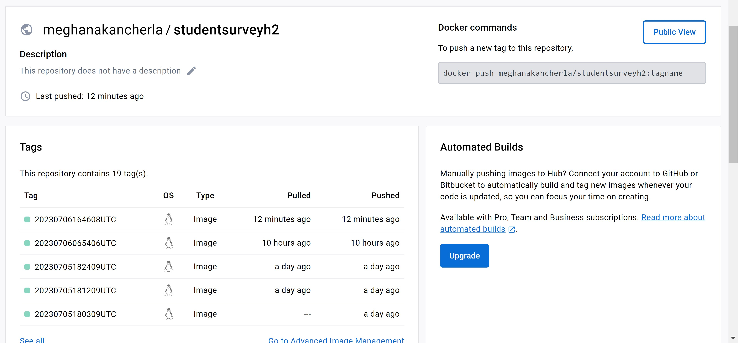

1. **The same time stamp is reflected in rancher:**

1. **The url to access the webpage is found in services**

1. **Webpage launched in Kubernetes Load Balancer service:**

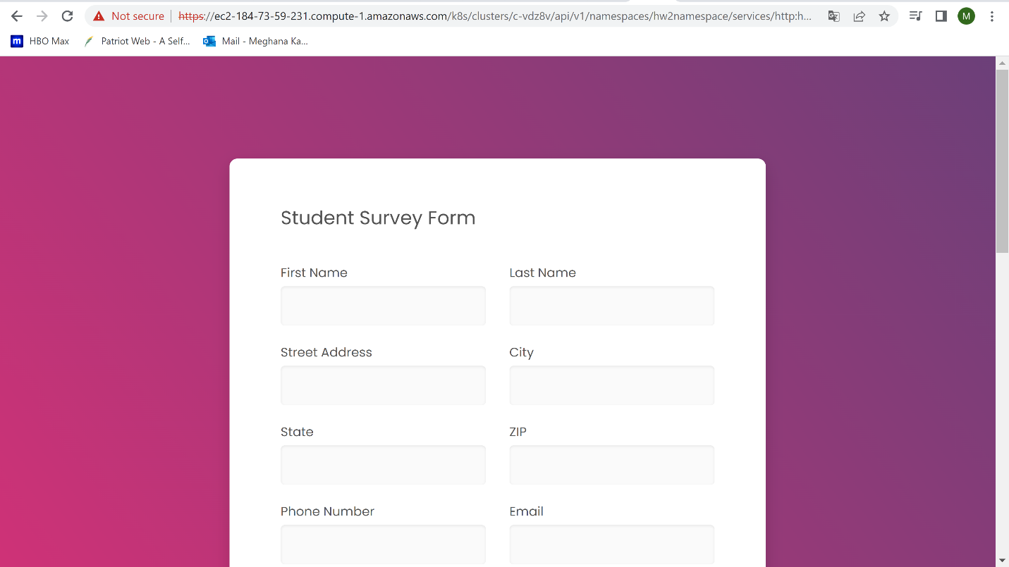

1. **Webpage launched in Kubernetes Node Port service:**

